**Box Pile Prefabs - Documentation**

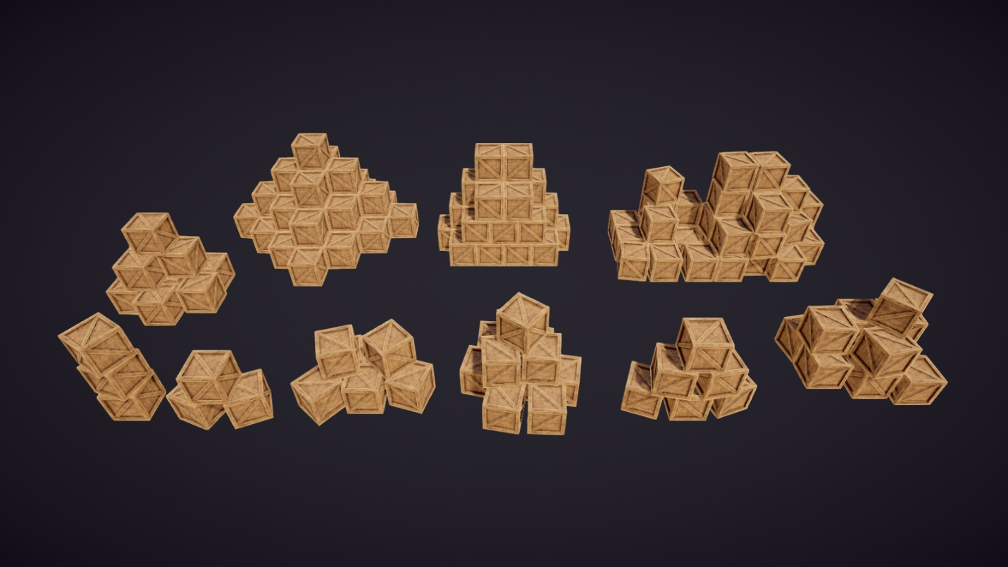

**Replacing Box Piles:**

Instead of manually replacing objects one by one, you may replace the cubes on the provided prefabs with the box-shaped object of your choice. However, there are some requirements your object must meet beforehand so that it does not get rejected by the replacement process:

* The object must have a box collider.
* The box collider is uniform in size.
* The box collider’s center is at (0, y, 0), where y is either zero or half the collider’s size.

.

If your object does not meet all requirements, the replacement process will not execute, and a debug message will be logged onto the console instead. However, if your object does meet all the requirements, the remainder of the process is as simple as clicking the “Replace Boxes” button on the **<BoxPile>** component.

**Replacing Multiple Box Piles at Once:**

The **<BoxPileGroup>** component functions similarly to its **<BoxPile>** counterpart, though it can replace multiple box piles at once.

To start replacing multiple box piles, you must parent all the box pile objects you want to replace onto a game object that contains a **<BoxPileGroup>** component. You may then proceed to set your object in the replacement field and press the “Replace Boxes” button in the inspector.

If you no longer want a specific box pile to be affected by the group replacement process, simply unparent the object from the **<BoxPileGroup>** object.

**Making Your Own Box Piles:**

You may also make your own set of box piles that can be replaced with different box objects. To make your own set valid for replacement, all objects in the pile must have a centered box collider that is uniform in size. Once you are done arranging your boxes, parent all the box objects to an empty game object and attach the **<BoxPile>** component to the empty game object.